3 Way 10" SoHo Horizontal Mounted PDU - UK Sockets (PDU-3WS-H-SOHO)

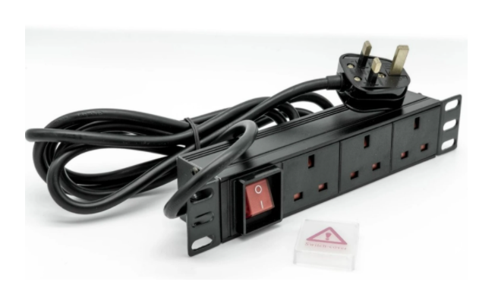

Description:

The LMS Power PDU-3WS-H-SOHO is a high-quality 10-inch Rackmount PDU (Power Distribution Unit) that simply fits within the compact, 10-inch SoHo (Small Office Home Office) range of wall cabinets.
A must-have accessory for your data cabinets if you need to provide effective power to devices including Ethernet Switches, Servers, UPS, NAS and of course cabinet accessories including cooling fan trays.
Robust, alloy design complete with rackmount brackets fitted, high-quality Neon Switch and of course UK output sockets together with a high quality, BSI-fitted
13 Amp UK plug.

Key Features:
Standard UK 3-Pin power outlets for your appliances
1U high means, 10" Wide for the small 10" SoHo cabinet
Neon On/Off Rocker switch to prevent accidental turn off
Backed up by LMS Power's exclusive 3-year warranty

Applications:
Create instant power feeds to your data, telecom or server cabinets
Provide effective power for cabinet cooling fans, UPS systems
Ideal as stand-alone trailing sockets outside the cabinet

Product Code:
Part Number: PDU-3WS-H-SOHO
EAN: 8400800035882
Weight: 0.5Kg approx

Technical Specifications:
Warranty LMS Data 3-Year Warranty
Chassis 1U 10-inch with mounting brackets
Output Sockets 3 UK 3-PIN Sockets
Power Input Fitted UK 3PIN BSI Plug 13 Amp
Flex Length 2.5 metres (approx)
Power Control On/Off Rocker Switch (illuminated)

Supplied With:
PDU-3WS-H-SOHO 3 Way Horizontal PDU
10-inch cabinet brackets (Fitted)
* Specifications and product design are subject to change. E&OE.

Looking for a costeffective, quality solution for providing power to your 10-inch wide, SoHo wall cabinets and enclosures? Introducing the new PDU-3WS-H-SOHO which is a compact, 10-inch wide general purpose PDU for supplying electrical power to other networking and active devices within a 10-inch wide data cabinet. Durable in design, featuring standard, x3 UK Power sockets with integral, illuminated rocker on/off switch together within a compact form-factor, ideal for mounting horizontally. Fitted with a generous 2.5 metre (approx.) power cable, terminated with a quality, 13 Amp UK plug, the PDU-3WS-H-SOHO is ideal for your 10-inch SoHo enclosure installations

specifications:
Standard 1U, 10-inch wide (25.3cm with brackets)
x3 UK-socketed 13A power outlets
Illumination On/Off power-input rocker switch
Supplied rackmount brackets (1 pair)
Generous 2.5 m (approx) flex with fitted UK 13-amp Plug
Ideal for the LMS Data 10-inch SoHo Cabinet range etc
Robust aluminium design - rear earthing stud
Dimensions: 25.3cm (W) x 4.5cm (H) x 4.5cm (D)

